

CIS017-1 – Computer Systems Structure
CIS095-1 – Databases and Computer Networking 2021-2022
Assignment 1 – Design and Implement a Database

INDIVIDUAL REPORT

Student ID: 2146504
BY : Baibhav Paudel

Table of Contents

Introduction / Overview………………………………………………………………………… 3
Task Description………………………………………………………………………………... 3
Tasks:
- Conceptual / Physical Database Design
  - Entity Relationship Model………………………………………………………………..4
  - Normalisation………………………………………………………………5
- Physical Database Design……………………………….6
- Implementation of the Database………………………………………………………...
- Query Design and implementation
Discussion / Critical Analysis / Reflection
Conclusion
References

Appendix

You will need to complete the Table of Contents and Page Nos manually

PLEASE NOTE THAT THIS IS A PROFESSIONAL REPORT
ALL SCREENSHOTS, DIAGRAMS, etc SHOULD BE GIVEN A FIGURE NUMBER AND A CAPTION AND AN EXPLANATION

Introduction/Overview

The purpose of the assignment is to study the fundamentals and structure of the database management system. Given assignment aid to acquire fundamental analytical and problem-solving abilities, it is important to collect information from various sources and utilize it to design, build, and implement a database system in order to complete the assignment.

Assignment Provide the data, scenario, and instructions, and a database management system is developed using the following data so that hotel personnel may manage, create, and remove data for the client. The client's registration is kept, along with the payment system of each customer. The major purpose of the assignment is to offer the hotel with a full hotel management system as well as a database system for managing all client data.

Following the instructions, entity relationship mode is defined, data normalization is performed, physical tables are designed, a query design is created, and the database system is implemented.

Task Description

A hotel database management system is about to introduce an online service where customers may check in, book, and plan their next holiday. The reservation is made in such a way that the room can only be allotted to one customer. Registered users can change or cancel their bookings. The hotel managers should be able to access all of the room data, whether it is available or not, and the booking must be accepted by the hotel manager in order for the reservation to be completed.
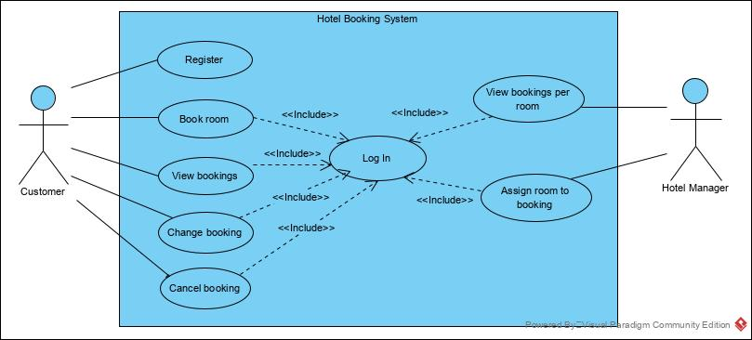

Tasks:

Conceptual / Logical Database Design

- Entity Relationship Model

    - Making an assumption To place a booking, a consumer must first register an account.
    - However bookings are not confirmed unless a hotel management accepts them.
    - The hotel management has access to every customers data as well as booking data, allowing them to determine whether or not a room is accessible to the customer.
    - Each Hotel manager are ssigned with many staff under them for required support.
    - Because the customers may only request one type of lodging at a time, each room must be booked separately.
    - Before the booking is utilized, the customer has complete ability to alter or delete there booking request.

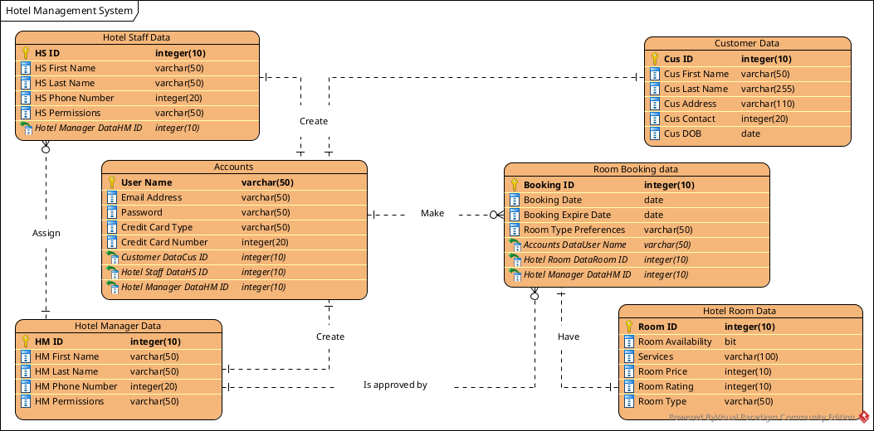
Figure 1: Entity Relationship Model for Hotel Management System

The following entities were defined for the Hotel Booking System: Customer Data, Accounts, Room Booking Data, Hotel Room Data, Hotel Manager Data, and Hotel Staff Data

Customers and accounts have the same relation in that a customer can only have one account.
Many bookings can be made from a single user account so, In hotel booking data, the account username is saved as a foreign key.
Accounts must be created by both employees and the management, so hotel manager data entity and hotel staff data entity are linked to the account entity in a one-to-one connection.
The manager then determines whether the room is available and approves it for the customer. As a result of this partnership, one hotel manager can authorize many bookings.Every booking may only reserve one kind of room, single or double, and each room requires a separate booking, therefore A one-to-one link exists between Booking Data and Hotel Room Data. Every hotel manager is given a team of hotel employees to work under them and assist them with client demands.

- Normalisation – Hotel Booking System
UNF | 1NF | 2NF | 3NF
Cus Id | Cus Id | Cus Id | Cus Id
Cus First Name | Cus First Name | Cus First Name | Cus First Name
Cus Last Name | Cus Last Name | Cus Last Name | Cus Last Name
Cus Contact | Cus Contact | Cus Contact | Cus Contact
Cus Address | Cus Address | Cus Address | Cus Address
Cus DOB | Cus DOB | Cus DOB | Cus DOB
User name
Email Address | Booking Id | User name | User name
Password | Booking Date | Email Address | Email Address
Credit Card Type | Booking Expire Date | Password | Password
Credit Card Number | Room Type Preferences | Credit Card Type | Credit Card Type
Booking Id | HM ID | Cre3dit Card Number | Credit Card Number
Booking Date | HM First Name | Customer DataCus ID* | Customer DataCus ID*
Booking Expire Date | HM Last Name |  | Hotel Staff DataHS ID*
Room Type Preferences | HM Phone Number | Booking Id | Hotel Manager DataHM ID*
HM ID | HM Permissions | Booking Date
HM First Name | HS ID | Booking Expire Date | Booking Id
HM Last Name | HS First Name | Room Type Preferences | Booking Date
HM Phone Number | Hs Last Name | HM ID | Booking Expire Date
HM Permissions | HS Phone Number | HM First Name | Room Type Preferences
HS ID | HS Permission | HM Last Name | Accounts DataUser Name*
HS First Name | Room ID | HM Phone Number | Hotel Room DataRoom ID*
Hs Last Name | Room Availability | HM Permissions | Hotel Manager DataHM ID*
HS Phone Number | Services | HS ID
HS Permission | Room Price | HS First Name | HM ID
Room ID | Room Rating | Hs Last Name | HM First Name
Room Availability | Room Type | HS Phone Number | HM Last Name
Services | Accounts DataUser Name* | HS Permission | HM Phone Number
Room Price |  | Room ID | HM Permissions
Room Rating | User name | Room Availability
Room Type | Email Address | Services | HS ID
 | Password | Room Price | HS First Name
 | Credit Card Type | Room Rating | Hs Last Name
 | Credit Card Number | Room Type | HS Phone Number
 | Customer DataCus ID* | Accounts DataUser Name* | HS Permission
 |  |  | Hotel Manager DataHM ID*
 |  |  | Room ID
 |  |  | Room Availability
 |  |  | Services
 |  |  | Room Price
 |  |  | Room Rating
 |  |  | Room Type
UNF data is generated by assessing all of the situations and data given.
1NF: Separation of attributes that hold the repating group.
2NF: Attributes are split so that all non-key attributes are completely reliant on the primary key.
3NF: Elimination of transitive dependency.
Physical Database Design

- Skeleton Tables

Customer Data (Cus Id, Cus First Name, Cus Last Name, Cus Contact, Cus Address, Cus DOB)

Accounts (User name, Email Address, Password, Cradit Card Type, Cradit Card Number, Customer DataCus ID*, Hotel Staff DataHS ID*, Hotel Manager DataHM ID*)

Room Booking Data (Booking Id, Booking Date, Booking Expire Date, Room Type Preferences, Accounts DataUser Name*, Hotel Room DataRoom ID*, Hotel Manager DataHM ID*)

Hotel Manager Data (HM ID, HM First Name, HM Last Name, HM Phone Number, HM Permissions)

Hotel Staff Data (HS ID, HS First Name, HS Last Name, HS Phone Number, HS Permissions)

Hotel Room Data (Room ID, Room Availability, Services, Room Price, Room Rating, Room Type)

Data Dictionary (for each table)

Customer Data
Description: Customer details
Field Name | Datatype | Length | Index | Null | Default | Validation rule | Description
Cus Id (Primary) | integer(10) | 10 | PK | No
Cus First Name | varchar(50) | 50 |  | No
Cus Last Name | varchar (50) | 50 |  | No
Cus Address | varchar(110) | 110 |  | No
Cus Contact | integer(20) | 20 |  | No
Cus DOB | date |  |  | No

Indexes
Keyname | Type | Unique | Column | Null
PRIMARY | BTREE | Yes | Cus ID | No

Accounts
Description: All Registered Data
Field Name | Datatype | Length | Index | Null | Default | Validation rule | Description
User Name (Primary) | varchar(50) | 50 | PK | No
Email Address | varchar(50) | 50 |  | No
Password | varchar (50) | 50 |  | No
Credit Card Type | varchar(50) | 50 |  | No
Credit Card Number | integer(20) | 20 |  | No

Indexes
Keyname | Type | Unique | Column | Null
PRIMARY | BTREE | Yes | User Name | No

Hotel Manager Data
Description: Hotel Manager details
Field Name | Datatype | Length | Index | Null | Default | Validation rule | Description
HM ID (Primary) | integer(10) | 50 | PK | No
HM First Name | varchar(50) | 50 |  | No
HM Last Name | varchar (50) | 50 |  | No
HM Phone Number | integer(20) | 20 |  | No
HM Permissions | varchar (50) | 50 |  | No

Indexes
Keyname | Type | Unique | Column | Null
PRIMARY | BTREE | Yes | HM ID | No

Hotel Staff Data
Description: Hotel Staff details
Field Name | Datatype | Length | Index | Null | Default | Validation rule | Description
HS ID (Primary) | integer(10) | 50 | PK | No
HS First Name | varchar(50) | 50 |  | No
HS Last Name | varchar (50) | 50 |  | No
HS Phone Number | integer(20) | 20 |  | No
HS Permissions | varchar (50) | 50 |  | No

Indexes
Keyname | Type | Unique | Column | Null
PRIMARY | BTREE | Yes | HS ID | No

Room Booking data
Description: Details for all the booking
Field Name | Datatype | Length | Index | Null | Default | Validation rule | Description
Booking ID (Primary) | integer(10) | 10 | PK | No
Booking Date | date |  |  | No
Booking Expire Date | date |  |  | No
Room Type Preferences | varchar(50) | 20 |  | No

Indexes
Keyname | Type | Unique | Column | Null
PRIMARY | BTREE | Yes | Booking ID | No

Hotel Room Data
Description: Room details
Field Name | Datatype | Length | Index | Null | Default | Validation rule | Description
Room ID (Primary) | integer(10) | 10 | PK | No
Room Availability | bit |  |  | No
Services | varchar(100) | 100 |  | No
Room Price | integer(10) | 10 |  | No
Room Rating | integer(10) | 10
Room Type | varchar(50) | 50

Indexes

Keyname | Type | Unique | Column | Null
PRIMARY | BTREE | Yes | Room ID | No

Implementation of the Database

For this practical task, you can use almost any RDMS – MySQL, SQLite, Oracle, Oracle Application Express (APEX) but you should not use MS Access.

YOU NEED TO STATE WHAT RDMS YOU ARE USING.

Write and execute SQL statements to create your database table structures including Primary Key and Foreign Key constraints.

Write and execute SQL statements to insert at least two rows of data in each table. Further records can be added manually.

You should create screenshots of the implementation to show the successfully created tables – structure and data, and the results of running your queries.

It may be possible (depending on platform and version) to also produce a screenshot of the set of tables created with the relationships between them.

Everything ie. SQL statements and output/result needs to be documented with screenshots or copy and pasted code.

Remember those Fig Nos, captions and explanations.

Query Design and Implementation

Use your SQL skills to design a set of relevant SQL queries and demonstrate your knowledge of SQL. Five (5) or six (6) queries will be sufficient but should include querying from multiple tables, using aliases, summary queries and grouping. The more complex and relevant the query is the more marks you are likely to achieve.

You show include the purpose of each query in terms of relevance to the business and in the context of the given scenario. You also need to include and exaplain the code, and show the results of running the code

Your SQL query designs should be included in your report, and you should include an explanation of the purpose of the query.

Execute SQL commands to create the queries you have designed. Run and test the queries.

Everything ie. SQL statements and output/result needs to be documented with screenshots or copy and pasted code.

Remember those Fig Nos, captions and explanations!

Discussion / Critical Analysis / Reflection
This part is important.

Basically, you are evaluating what you have done. Did you achieve all the required specification of the Assignment brief? If not, why not? Discuss the problems you encountered and how you overcame them.

Did you give yourselves enough time to accomplish this work? Was it harder than you expected? What have you learned from tackling this Assignment?

Did this work enhance your understanding of the database design and implementation programming language? Did it motivate you to learn more SQL and about NoSQL databases?

If you had to undertake this or something similar again would you tackle it differently?

What improvements or enhancements would you recommend for a future iteration of this project?

Conclusion
What were you asked to do? Did you achieve it?

References
Harvard Referencing System. Any reference must be cited in text

Appendix

If needed!
Anything else that you might want to include that does not fit well into the main report body.

